This QRG outlines the steps to re-open a calendar to make schedule edits. Once a calendar is submitted to Payroll the status in the SEEMLESS application is changed to Processed. Any changes to a calendar with a status of Processed must be re-opened. The Business Office can only perform these tasks.

Access the Summer Pay Tool
Visit OneCampus and select SEEMLESS. | https://one.purdue.edu/  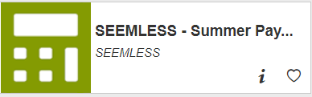
Log in using Purdue Career Account ID and Password | 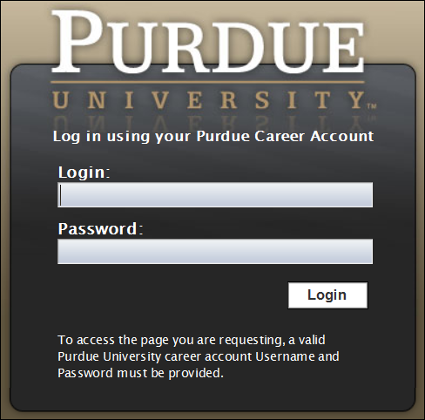

Re-Open Calendar
Once logged in, the Dashboard is displayed.
Click Calendar Management.
Click the ALL tab to display all calendars.  Click the Advanced Search to open the additional options. | 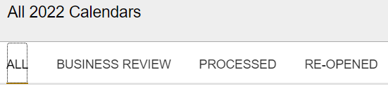
Search by the employee’s information (PERNR, Career Account)

Click Search at the far right

Highlight the pay period needed and then either select View or click twice on the line to open the calendar. | 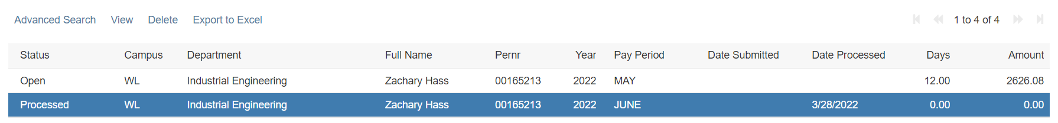
Select Re-open Calendar at the bottom of the screen.  A confirmation box will open to confirm your selection. Click YES, Re-open this calendar.  The status of the calendar will change to Re-opened. | 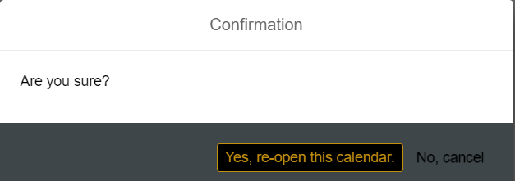
Update the calendar as needed. | 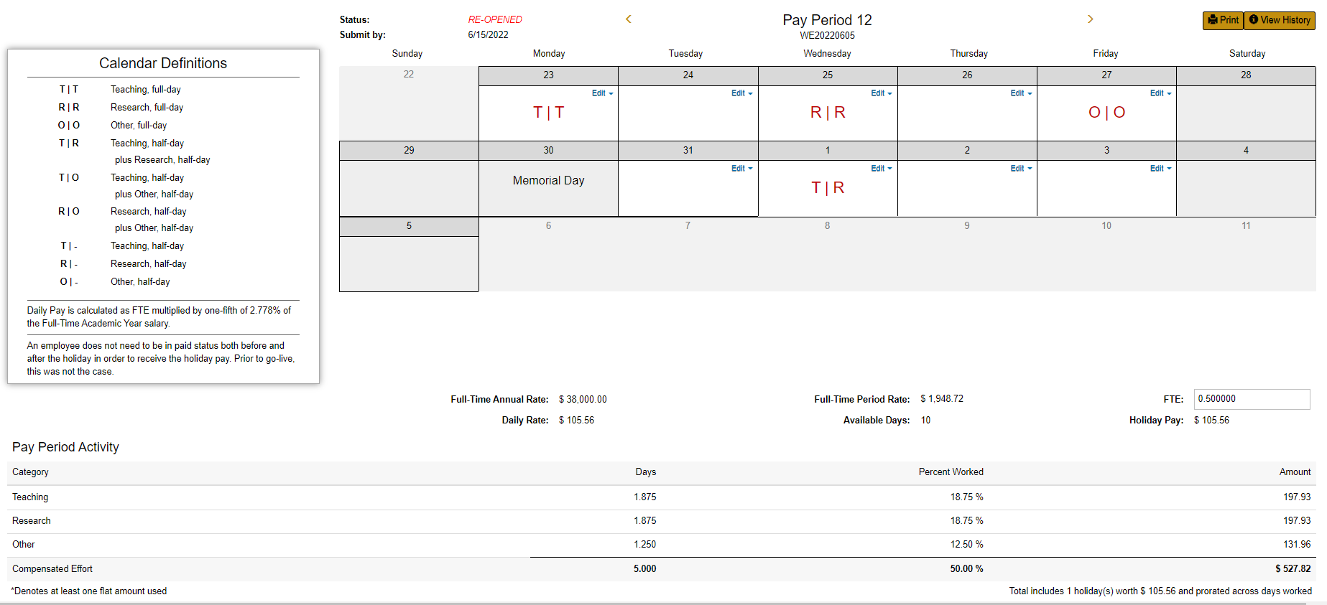
Click Review Before Re-Submission
Changes are highlighted in yellow. | 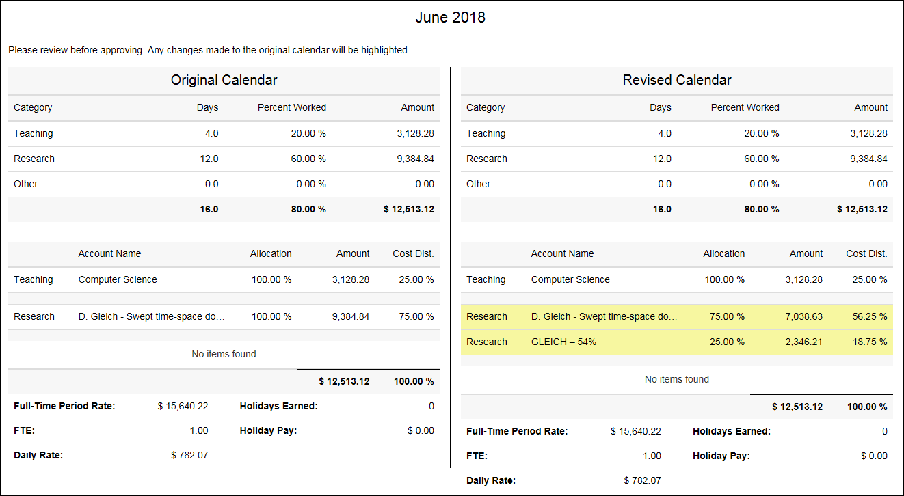
Click Submit Calendar.
Click Yes, proceed. | 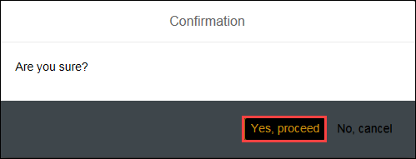
Click OK.  Verify the entries posted in IT15 in ECP. | 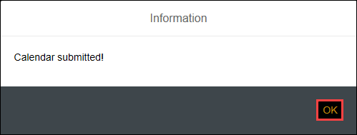

Retro Pay
From the Faculty Overview, click Retro Pay. | 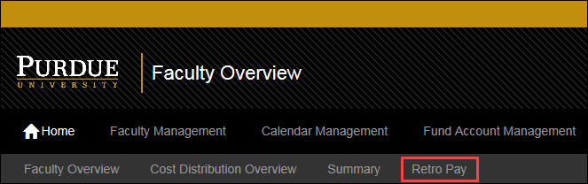
All retro pay activities are displayed. | 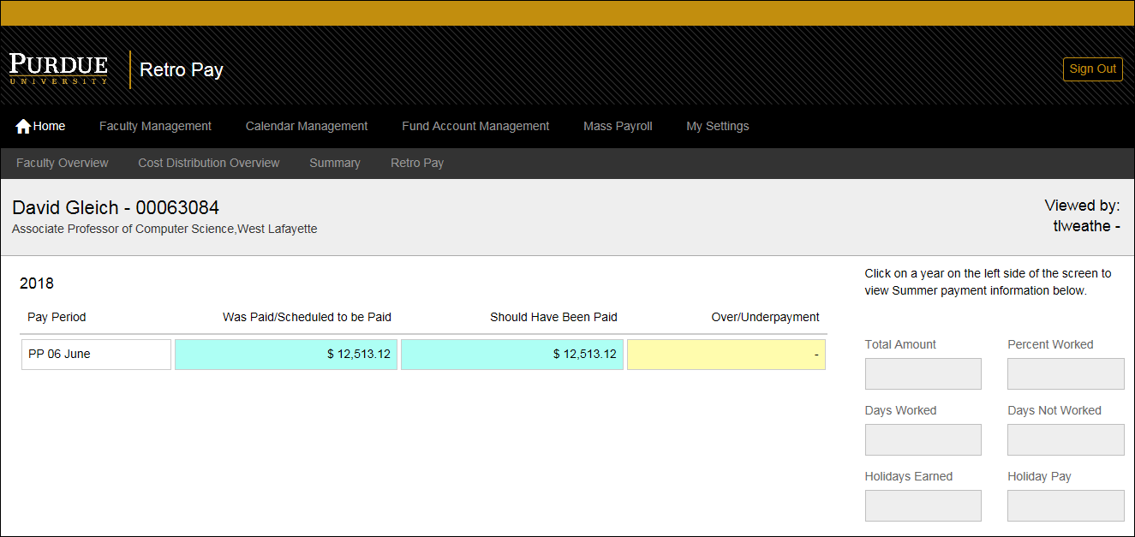
Click on the year to Highlight the summary of the Summer Pay | 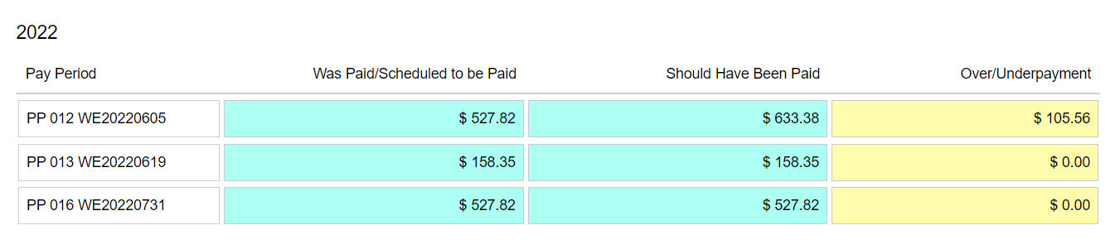
Details are displayed to the right of the selection. | 